Task1:
Determine if String Halves Are Alike

Aim:- To determine the two halves of a given even-length string are alike by checking if both halves contain an equal number of vowels.

Algorithm:-
- Start
- Read the input string s.
- Find the midpoint of the string using mid = length / 2.
- Initialize two counters countA and countB to zero.
- Define a string containing all vowels (both uppercase and lowercase).
- Traverse from index 0 to mid - 1:
- If the character in the first half is a vowel, increment countA.
- If the corresponding character in the second half is a vowel, increment countB.
- Compare countA and countB.
- If both counts are equal, return true; otherwise, return false.
- stop

Program:-
class Solution {
public boolean halvesAreAlike(String s) {
int n = s.length(), count = 0;
String vowels = "aeiouAEIOU";
for (int i = 0; i < n / 2; i++)
if (vowels.indexOf(s.charAt(i)) >= 0) count++;
for (int i = n / 2; i < n; i++)
if (vowels.indexOf(s.charAt(i)) >= 0) count--; return count == 0;
}
}

Output:-

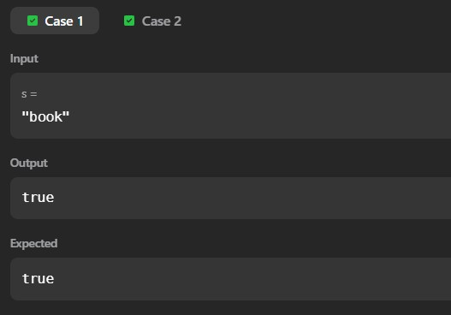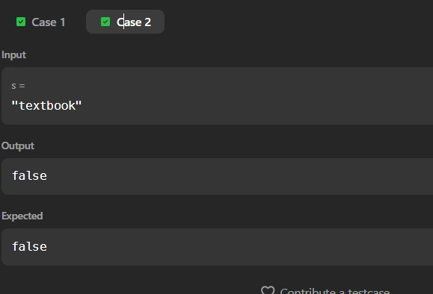

Result:-Thus, To determine the two halves of a given even-length string are alike by checking if both halves contain an equal number of vowels is are successfully executed.
Task2:
LAPIN
Aim:- To check whether a given string is a lapindrome. A string is said to be a lapindrome if, after splitting it into two halves (ignoring the middle character if the length is odd), both halves contain the same characters with the same frequency.

Algorithm:-
- Start.
- Read the number of test cases T.
- For each test case:
  - Read the string S. o Find the length n of the string. o Calculate the middle index mid = n / 2.
- Create two frequency arrays of size 26 (for lowercase English letters).
- Count the frequency of characters in the first half of the string.
- Count the frequency of characters in the second half of the string:
  - If the string length is odd, skip the middle character.
- Compare both frequency arrays:
  - If all frequencies match, the string is a lapindrome.
  - Otherwise, it is not a lapindrome.
- Print "YES" if the string is a lapindrome, else print "NO".
- Stop

Program :-
import java.util.*;

class Codechef {
public static void main(String[] args) throws java.lang.Exception {
Scanner sc = new Scanner(System.in);
int T = sc.nextInt();
while (T-- > 0) {
String s = sc.next();
int n = s.length();
int[] freq1 = new int[26], freq2 = new int[26];
int mid = n / 2;
for (int i = 0; i < mid; i++) freq1[s.charAt(i) - 'a']++;
for (int i = (n % 2 == 0 ? mid : mid + 1); i < n; i++) freq2[s.charAt(i) - 'a']++;
boolean isLapindrome = true;
for (int i = 0; i < 26; i++) {
if (freq1[i] != freq2[i]) {
isLapindrome = false;
break;
}
}
System.out.println(isLapindrome ? "YES" : "NO");
}
sc.close();
}
}

Output:-
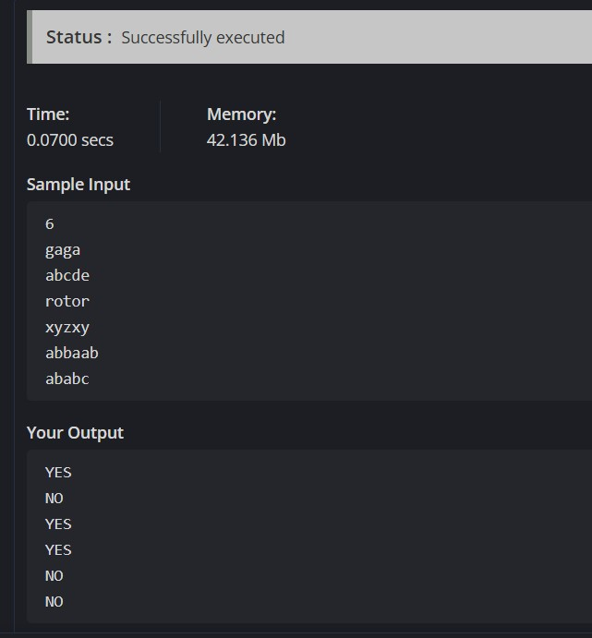

Result:-Thus,The program successfully identifies whether each given string is a lapindrome or not by comparing the character frequencies of its two halves and displays “YES” for lapindrome strings and “NO” for non-lapindrome strings is are successfully executed.
Task3:
Compare the Triplets

Aim:- To implement a java code for Compare the Triplets using loops.

Algorithm:-
- Input:
  - Read Alice’s triplet a[0], a[1], a[2].
  - Read Bob’s triplet b[0], b[1], b[2].
- Initialize scores:
  - alice = 0
  - bob = 0
- Comparison loop: For each index i from 0 to 2:
  - If a[i] > b[i], increment alice.
  - Else if a[i] < b[i], increment bob.
  - Else (equal), do nothing.
- Print Alice’s score and Bob’s score as [alice, bob].

Program:-
import java.util.*;
public class Solution {
public static void main(String[] args) {
Scanner sc = new Scanner(System.in);
int[] a = new int[3];
int[] b = new int[3];
for (int i = 0; i < 3; i++) a[i] = sc.nextInt();
for (int i = 0; i < 3; i++) b[i] = sc.nextInt();
int alice = 0, bob = 0;
for (int i = 0; i < 3; i++) {
if (a[i] > b[i]) alice++;
else if (a[i] < b[i]) bob++;
}
System.out.println(alice + " " + bob);
}}

Output:-


Result:- Thus, To implement a java code for Compare the Triplets using loops is are successfully executed.
Task4:
Contains Duplicate
Aim:- To determine whether an integer array contains any duplicate values. Return true if at least one value appears more than once, otherwise return false.

Algorithm:-
- Input: An integer array nums.
- Initialize a data structure:
- Use a HashSet to store unique elements.
- Iterate through the array:
- For each element n in nums:
  - Try to add n to the set.
  - If adding fails (element already exists), return true.
- If loop completes:
- No duplicates found → return false.

Program:-
import java.util.*;
import java.util.stream.*;
class Solution {
public boolean containsDuplicate(int[] nums) {
return Arrays.stream(nums).distinct().count() < nums.length;
}
}

Output:-
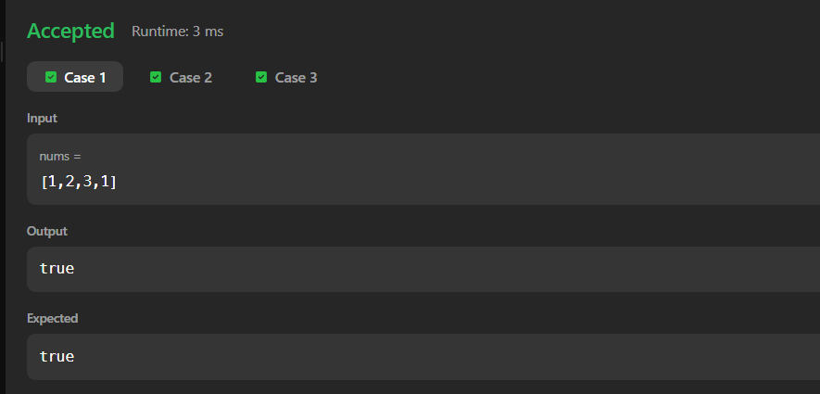

Result:-Thus, To determine whether an integer array contains any duplicate values. Return true if at least one value appears more than once, otherwise return false verified successfully.
Task5:
Time Conversion

Aim:- To convert a given time in 12-hour AM/PM format into 24-hour military time format.

Algorithm:-
- Input: A string s representing time in the format hh:mm:ssAM or hh:mm:ssPM.
- Extract components:
  - Hours (hh), minutes (mm), seconds (ss), and the period (AM/PM).
- Conversion rules:
  - If the period is AM:
    - If hh == 12, set hh = 00.
    - Else keep hh unchanged.
  - If the period is PM:
    - If hh != 12, add 12 to hh.
- Format result:
  - Return the string in HH:MM:SS format (24-hour).

Program:-
import java.util.*;
class Solution {
public static String timeConversion(String s) {
String period = s.substring(8);
int hour = Integer.parseInt(s.substring(0, 2));
if (period.equals("AM")) {
if (hour == 12) hour = 0;
} else {
if (hour != 12) hour += 12;
}
return String.format("%02d:%s", hour, s.substring(3, 8));
}

public static void main(String[] args) {
Scanner sc = new Scanner(System.in);
String s = sc.next();
System.out.println(timeConversion(s));
}
}

Output:-


Result:-Thus, To convert a given time in 12-hour AM/PM format into 24-hour military time format is are successfully executed.
Task6:
Move Zeroes

Aim:- To move all zeroes in an integer array to the end while keeping the relative order of the non-zero elements intact. The operation must be done in-place (no extra copy of the array).

Algorithm:-
- Input: An integer array nums.
- Initialize a pointer: pos = 0 (tracks the position to place the next non-zero).
- First pass:
- Iterate through the array.
- For each non-zero element, assign it to nums[pos] and increment pos.
- Second pass:
- From index pos to the end of the array, fill with zeroes.
- The modified array with all non-zero elements in order followed by zeroes.

Program:-
class Solution {
public void moveZeroes(int[] nums) {
int pos = 0;
for (int n : nums) if (n != 0) nums[pos++] = n;
while (pos < nums.length) nums[pos++] = 0;
}
}

Output:-
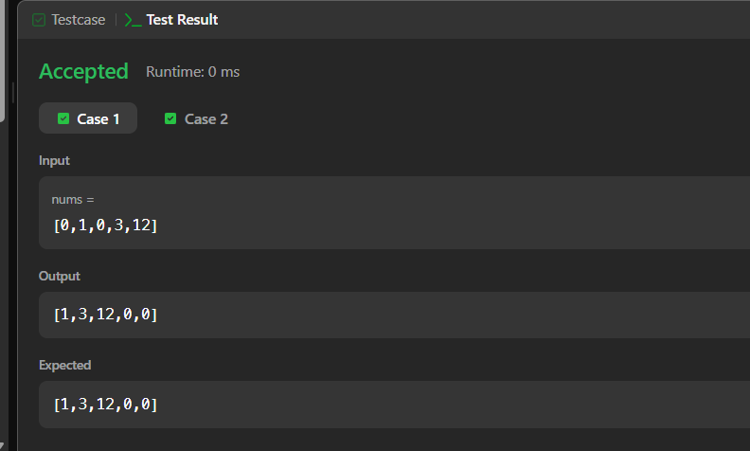

Result:-Thus, To move all zeroes in an integer array to the end while keeping the relative order of the non-zero elements intact. The operation must be done in-place (no extra copy of the array) is are successfully executed.
Task7:
Diagonal Difference
Aim: -To calculate the absolute difference between the sums of the primary diagonal and the secondary diagonal of a square matrix.

Algorithm:-
- Input:
- An integer n (size of the matrix).
- An n × n matrix arr.
- Initialize sums:
- primary = 0
- secondary = 0
- Loop through rows: For each index i from 0 to n-1:
- Add arr[i][i] to primary (primary diagonal).
- Add arr[i][n-1-i] to secondary (secondary diagonal).
- Compute difference:
- result = ”primary – secondary”
- Print or return result.

Program:-
import java.util.*;

class Solution {
public static int diagonalDifference(int[][] arr) {
int n = arr.length, primary = 0, secondary = 0;
for (int i = 0; i < n; i++) {
primary += arr[i][i];
secondary += arr[i][n - 1 - i];
}
return Math.abs(primary - secondary);
}

public static void main(String[] args) {
Scanner sc = new Scanner(System.in);
int n = sc.nextInt();
int[][] arr = new int[n][n];
for (int i = 0; i < n; i++)
for (int j = 0; j < n; j++)
arr[i][j] = sc.nextInt();
System.out.println(diagonalDifference(arr));
}
}

Output:-
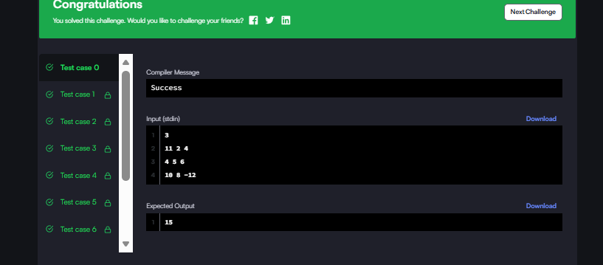

Result:-Thus, To calculate the absolute difference between the sums of the primary diagonal and the secondary diagonal of a square matrix is are successfully executed.
Task8:
Transpose Matrix
Aim:-To return the transpose of a given 2D integer matrix. The transpose is formed by flipping the matrix over its main diagonal, switching rows with columns.

Algorithm:
- Input: A 2D integer array matrix of size m × n.
- Initialize: A new 2D array result of size n × m.
- Loop through elements:
- For each element at position (i, j) in the original matrix, place it at (j, i) in the result.
- Return the result matrix.

Program:-
class Solution {
public int[][] transpose(int[][] matrix) {
int m = matrix.length, n = matrix[0].length;
int[][] result = new int[n][m];
for (int i = 0; i < m; i++)
for (int j = 0; j < n; j++)
result[j][i] = matrix[i][j];
return result;
}
}

Output:-
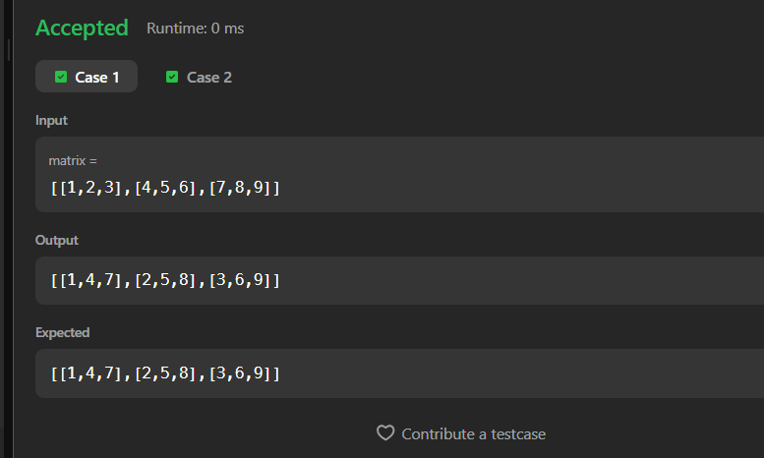

Result:Thus, To return the transpose of a given 2D integer matrix. The transpose is formed by flipping the matrix over its main diagonal, switching rows with columns is are successfully executed.

